Final Project – Joshua Ellington and Kevin Dustin

#000000

#404040

#333F50

#87000F

#FFFFFF

We have decided to build a site for a car dealership. The color palette we chose was to reflect the kind of colors you might see in luxury or sports cars. A lot of the page will be white with bars, links and such utilizing the darker colors. We’ll use the red to add accents where we want to really draw attention. This will include things like links and highlighting outlines when the user hovers over something they can click.

The main page will have a gallery of the nicest cars just below the header to really grab attention. The rest of the page will mostly be marketing type talking about how great we are with a map on the right side showing our location.

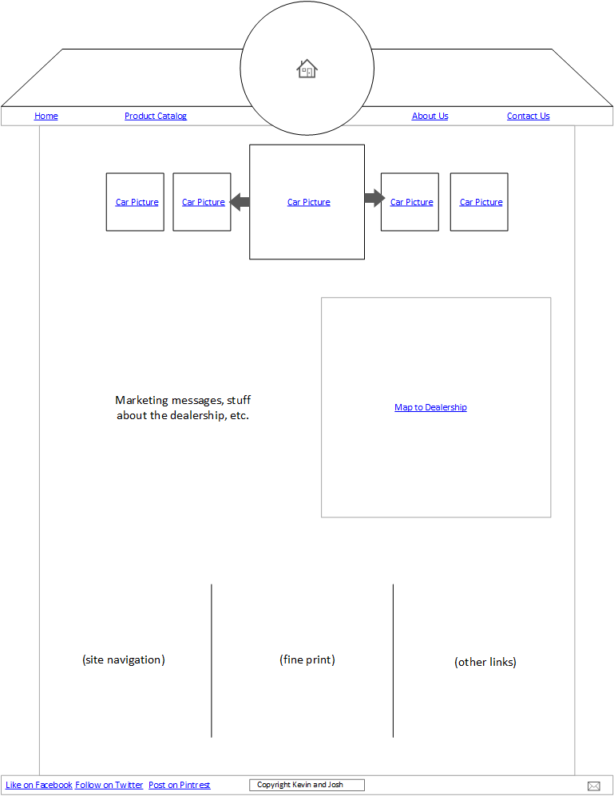

Our about and contact pages will be pretty straightforward.

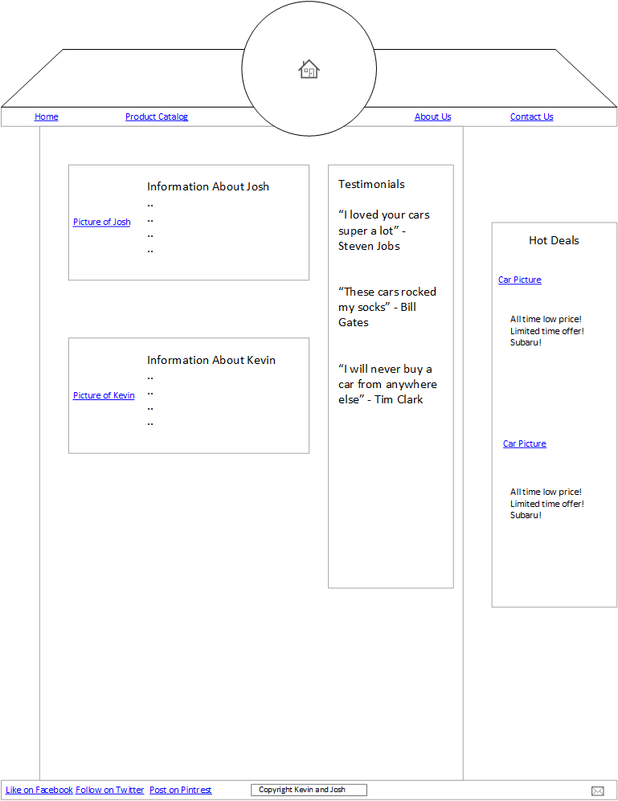 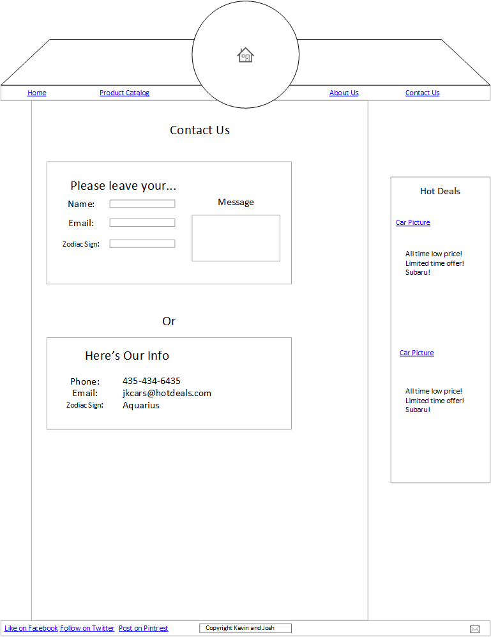

The product catalog will display listings like you would normally see on a site selling automobiles.

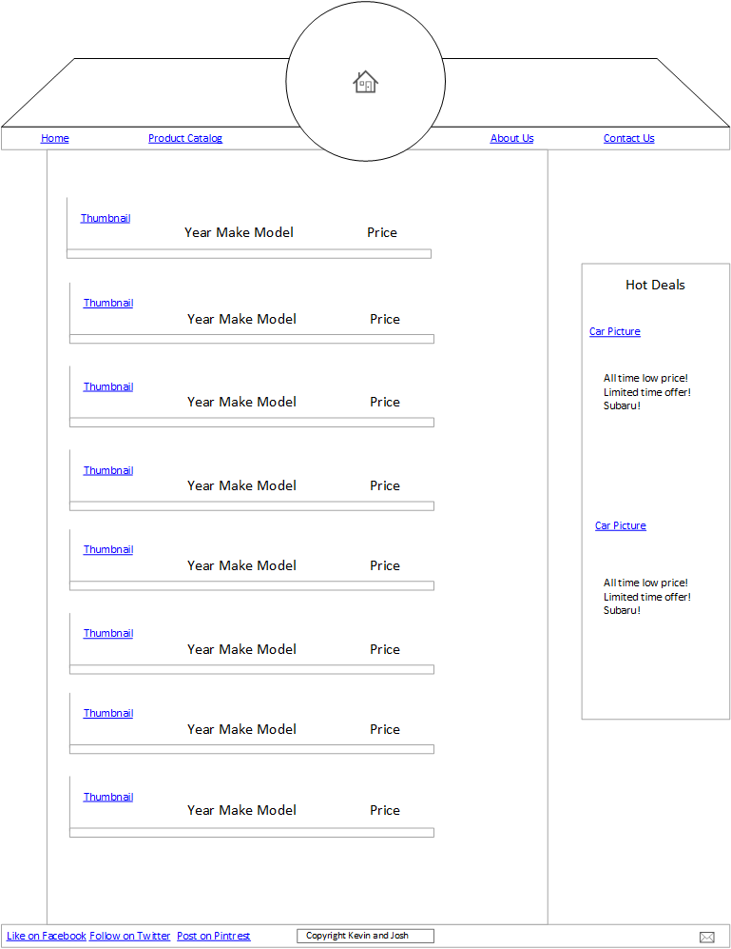

For the product details we’ll be utilizing a sort of modal dialog that will include detailed information about the selected automobile as well as a scrolling gallery of pictures in the top left.

